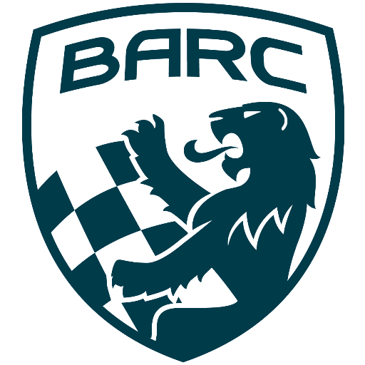

British Automobile Racing Club

General Membership Meeting Minutes – February 4th. 2025

Venue - Texas Lone Star Grill, Dixon Road, Etobicoke, ON.

WELCOME – 20:12 Bryan Rashleigh, President

MINUTES

The secretary read the minutes as there was an issue posting them to the website. Amy Harrison made a motion to accept the minutes which was seconded by Keith Whorley and carried.

CORRESPONDENCE

There was nothing new to report.

DEPARTMENTS

MEMBERSHIP Andrea Pegg, Membership Secretary

There are currently 51 members with 3 being new members.

TREASURY John Bordin, Treasurer

We are financially sound.
We have received the information on the CTMP 2025 track rental fees.

WRRC/SOCIAL

There was nothing to report.

REGIONAL RACE/ORO John Bordin, Race Director

The BARC TT will take place on the weekend of July 26th and 27th.
We are currently short of two series for the weekend.
Paul Einarsen mentioned a previous year’s event where the NESCCA competitors ran on the BARC weekend. He suggested reaching out to them.
We will need an Event Chief Scrutineer.

RACE COMMITTEE

There was a meeting on January 15th.
CASC will have a booth at Motorama on the weekend of March 7th to 9th. They will probably have a few race cars in the booth.
REV TV will probably play the video from last year.
TRS will be part of the CASC booth.
Registration for Spring Fling is now open.
There is a new entry fee structure for 2025.

HONDA INDY TORONTO David Bayley

The event will take place on the weekend of July 18th to 20th.

ICE RACING Wayne Wanamaker, Ice Race Organizer

All arrangements for the weekend are in place.
Wayne has volunteers for all positions.
The weather has been great and there have already been two great weekends of racing.
Bryan had two co-workers come to the previous race weekend and he took them around the track. They reportedly had an enjoyable time.

TRS Tom Cressman

Tom reported they will have their annual training in April as usual.
He will be doing a presentation at Conestoga College and will hopefully find a few more interested volunteers.

NEWSLETTER Amy Harrison

Amy sent the final standings of 2024 to the BARC UK.
She will send them pictures and standings at the end of the Ice Racing season.

OLD BUSINESS

There was no old business.

NEW BUSINESS

There was no new business.

Buy/Sell

David King has information on Beagles which are available to be adopted. However, they are diabetic and will require extra care.
Paul Einarsen has a Firebird convertible for sale and a motorhome. Please contact him directly if you are interested.

Adjournment

Wayne Wanamaker made a motion for adjournment which was seconded by
Amy Harrison at
20 :57

NEXT MONT H’S MEETING: at the Lone Star Texas Grill (upstairs) – March 4th, 2025, at 20:00.

