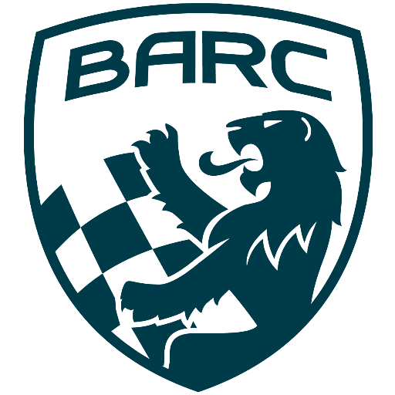

British Automobile Racing Club

General Membership Meeting Minutes -September 3rd, 2019

Venue - Texas Lone Star Grill, Dixon Road, Etobicoke, ON.

WELCOME – 20:08 Bryan Rashleigh, President

MINUTES

Bryan read the minutes of the previous meeting. Tom Cressman made a motion to accept the minutes and Bill Lobban seconded the motion, with those in attendance in agreement.

CORRESPONDENCE

Paul has received a couple of cheques and an invoice from the BARC TT, which he has paid.

DEPARTMENTS

MEMBERSHIP Andrea Pegg, Membership Secretary

There was no report as Andrea sent her regrets.
There was a question about who are the current Life Members. They are John Cosgrove, Scott Ellsworth, Ken Graham, Hugh Skully and Bill and Mary Lobban.
Phil Delahaye suggested we remember those Life Members who are no longer with us at the AGM.

TREASURY Paul Clarke, Treasurer

The treasurer reports we have money.
Anyone who has any receipts for expenses still in their possession should send them to Paul by the end of September, to ensure they are included in the current fiscal year.
He has sent the BARC donation to Brian Graham for the F1600 Team Canada trip to the F1600 festival in the UK.

WRRC

Howard is suggesting BARC have a display at Motorama in 2020. He is recommending a booth with an ice racer, open and closed wheel cars. Volunteers will be needed to staff the booth.
Bill Lobban said there are lots of booths at professional weekends and we should look at doing that to attract more volunteers. David King said MMS has a booth at all major weekends.

SOCIAL Howard Cohen

Bryan says the Board has been looking into planning a celebration to celebrate our 60th anniversary. Maybe also hand out the 2019 awards on that night.

REGIONAL RACE/ORO Scott Ellsworth, Race Director

David Bayley reported the VARAC 40th Anniversary Race at Shannonville was very successful with everyone enjoying the one day event. Bryan Rashleigh accepted a plaque from VARAC to BARC thanking us for 40 years of support to their club. Bill Lobban suggested posting this to Facebook. David suggested John Jensen’s photograph of the celebration should be sent to the BARC UK magazine.
Mary Lobban said that due to most of the F1600 drivers being BARC members, she heard BARC mentioned a lot at the NASCAR event.
Bill Lobban asked if drivers are given BARC decals with their membership. Also he does not think the decals state what ‘BARC’ means. He suggested adapting the decals to show our name. Phil suggested having a sign in the paddock with this new logo so people could make the connection.
The treasurer mentioned he still has lots of envelopes with the old logo and he still uses them. Wayne Wanamaker suggested discussing it at the next Board meeting. Maybe adding 1959 - 2019.

RACE COMMITTEE David King, BARC/Region Chief Scrutineer

Brian Graham has recommended region races at Calabogie, CTMP and Shannonville for the F1600 series. Ray Arlauskas will speak to Calabogie and MCO.

HONDA INDY TORONTO Scott Ellsworth

There is nothing new to report.

ICE RACING Wayne Wanamaker, Ice Race Director

The 2019 BARC Ice Prix will take place on February 8th and 9th. Wayne would like to be contacted, if you would like to volunteer.

TRS Tom Cressman

TRS has provided support for the VARAC anniversary race at Shannonville and OTA events.
They are looking to recruit and train members in 2019.
Paul Einarson asked about the ‘Jaws of Life’ and Tom reported they have been fixed.

NEWSLETTER

If anyone has submissions for the newsletter, they should contact Pat McDiarmid and any submissions for the BARC UK magazine, should be submitted to Amy McLeary.

OLD BUSINESS

There was a discussion about decals and membership hard cards. The Board will discuss the hard cards at the next meeting.
Phil Delahaye asked about race cars having the BARC decals and has the Board considered restarting the BARC Championship with payouts for drivers. When we last ran that program we had a sponsor and could afford it.
Paul Einarson said drivers should have at least two decals, one for each side of their car.
Bill Lobban said each new member should get a welcome letter, but he does not think we need hard cards.
Keith Whorley has again volunteered to make a telephone call to each new member welcoming them to the club. Paul Einarson mentioned this was offered before and asked the Board to discuss and follow up with Keith.

NEW BUSINESS

Phil Delahaye was in Oshkosh for the annual air show. During the weekend the control tower is the busiest in the world, with everything from biplanes to home made jets flying in for the event.
The Blancpain Gt World Series has an American division and Kyle Marcelli is competing with a car prepared by the Racers Edge Team. They are currently leading in the Pro/Am division. It is very exciting racing and can be seen on-line by typing ‘world challenge’.
David King reported on the Hurley Haywood documentary screening by Mini Grid, with Mr. Haywood in attendance. He suggested members join the Mini Grid website so they are updated on upcoming events.

Buy/Sell

Bryan Rashleigh still has his lightly used Powerfist generator.
Howard Cohen had some race memorabilia.
Paul Einarsom has a scooter carrier for sale for $200. Brian Rashleigh suggested posting it on the ice race forum.

Adjournment
Wayne Wanamaker made a motion for adjournment, which was seconded by Tom Cressman at 21:04.
.
NEXT MONTH’S MEETING: at the Lone Star Texas Grill (upstairs) – October 1st, 2019 at 8 pm.

