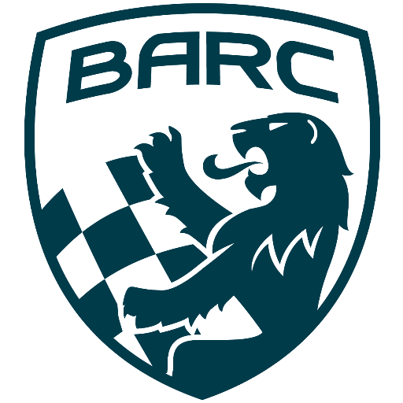

British Automobile Racing Club

General Membership Meeting Minutes – January 7th, 2025

Venue - Texas Lone Star Grill, Dixon Road, Etobicoke, ON.

WELCOME – 20:18 Bryan Rashleigh, President

MINUTES

Bryan made a motion to accept the minutes as if read, which was seconded by John Bordin and carried.
Bryan shared the sad news that long time member, former Marshal, President and Treasurer, Paul Clarke had succumbed to his illness.

DEPARTMENTS

MEMBERSHIP Andrea Pegg, Membership Secretary

In Andrea’s absence there was no report.

TREASURY John Bordin, Treasurer

After review by Stan Maleta and Keith Whorley, the Financial Statements have been approved to be presented to the membership. John is scheduling the March meeting for his presentation.
We are in a healthy financial position.

WRRC/SOCIAL

There was nothing new to report.

REGIONAL RACE/ORO John Bordin, Race Director

John held a meeting to review the season with key available volunteers. He will bring the information to his 2025 planning sessions.
The BARC TT was successful. The Peter Jackson vintage race did not have a large number of entries, but it was a fun day of racing. John thanked everyone for their help.

RACE COMMITTEE

There was no report.

HONDA INDY TORONTO David Bayley

There is currently no news other than the dates will be July 18th to 20th.

ICE RACING Wayne Wanamaker, Ice Race Organizer

In Wayne’s absence, Bryan reported the BARC Ice Prix will take place on February 8th and 9th.
He reported Elaine Willis is trying to attract sponsors.
Andrew Majik reported track building efforts are going well.
John Bordin had just returned from Haliburton and reported, cold temperatures and lots of snow. So, the weather looks good for the season.

TRS Tom Cressman

In Tom’s absence, Bryan reported plans are underway for the usual April training weekend.

OLD BUSINESS

There was no old business.

NEW BUSINESS

Scott Ellsworth is working on updating the BARC website.

NEWSLETTER Amy Harrison

Amy will only publish the newsletter when she receives content. She will post any updated news on the BARC Facebook page.
She will also send information, including our race schedule to the BARC in the UK.

Buy/Sell

There was nothing for Buy/Sell.

Adjournment

In Wayne’s absence at 20:39, Andrew Majic made a motion for adjournment which was seconded by John Jensen.

NEXT MONT H’S MEETING: at the Lone Star Texas Grill (upstairs) – February 4th, 2025, at 20:00.

